Conduct the **four** queries in Step a. Compare each timing result with its counterpart in Step a. Would you have any discovery from the comparison?

Query 1:

Showing all users from Nebraska:

Time: 0.0094 seconds

Time in step a: 0.355279 seconds

Query 2:  
Showing all the users that have sent messages between 8am and 9am:

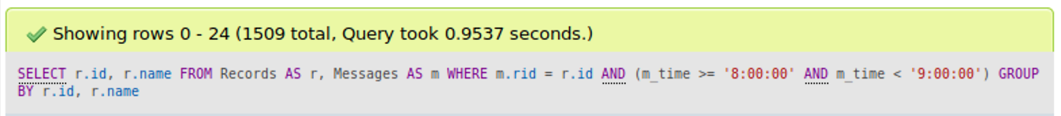

Time: 0.9537 seconds

Time in step a: 0.351296 seconds

Query 3:

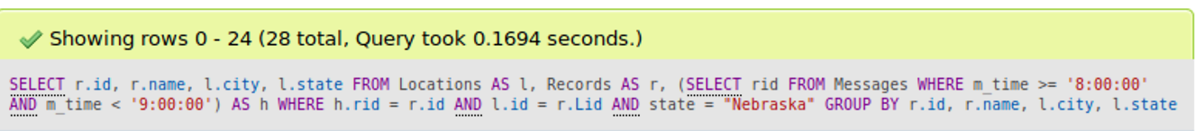

Time: 0.1694 seconds

Time in step a: 0.329150 seconds

Query 4:

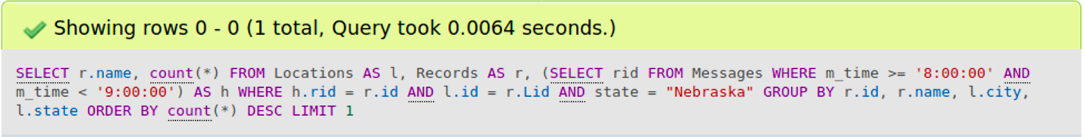

Time: 0.0064 seconds

Time in step a: 0.415893 seconds

The DBMS is faster at retrieving data and conducting queries compared to the file system, but it still takes a longer time to retrieve larger results, such as in query 2.